Roxanne Haines
Reel Breakdown

RoxanneHaines.com
rthaines97@gmail.com (615)739-8990

Image | My Role | Tools Used
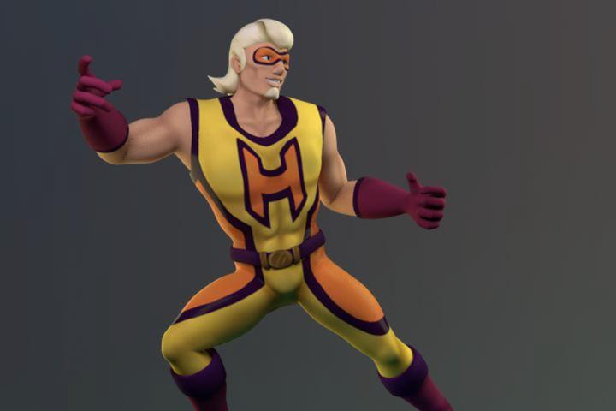 | All assets, excluding rigging | Maya, Mudbox, Photoshop
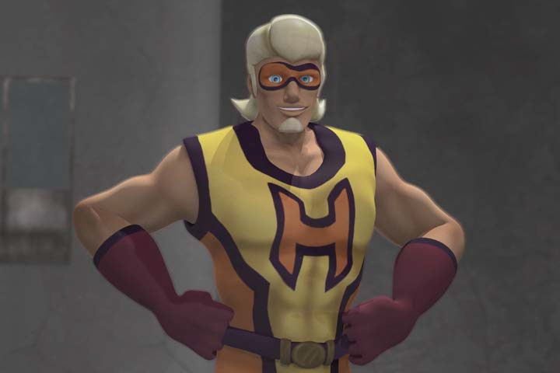 | Animation | Maya
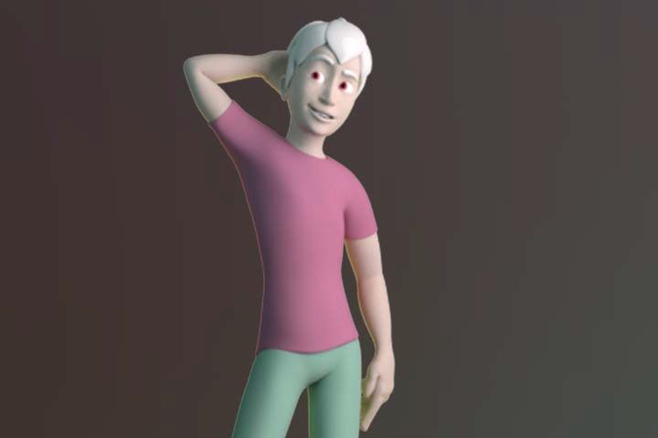 | All assets | Maya

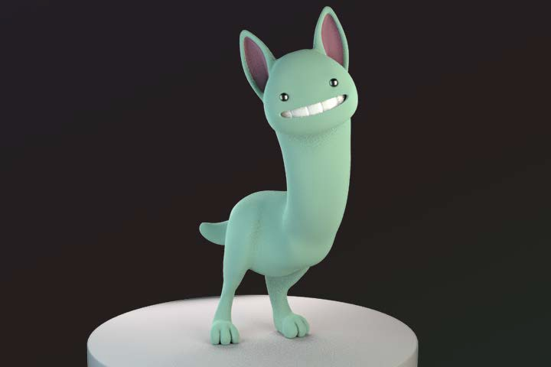 | All assets | Maya
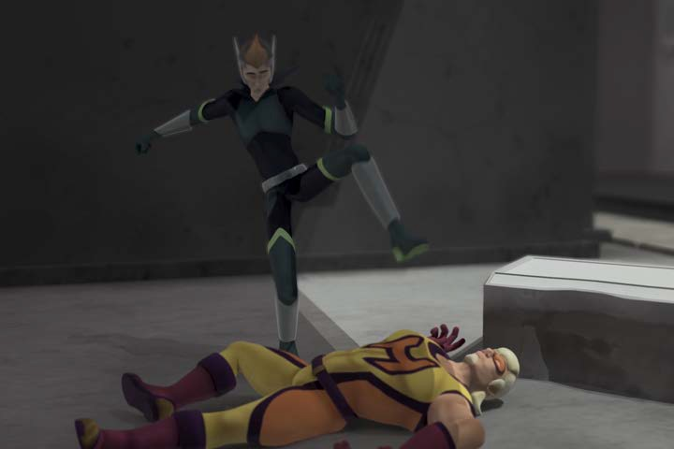 | Animation | Maya
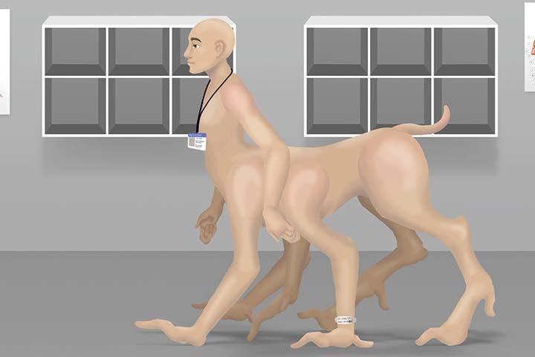 | All assets excluding background images | Photoshop, After Effects with Duik
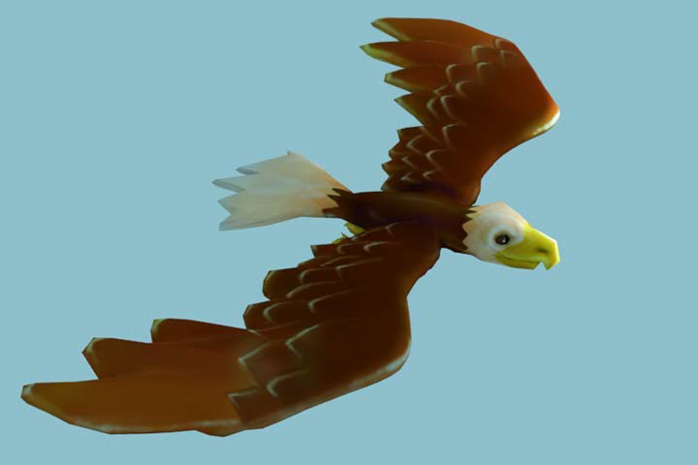 | All assets | Maya, Mudbox
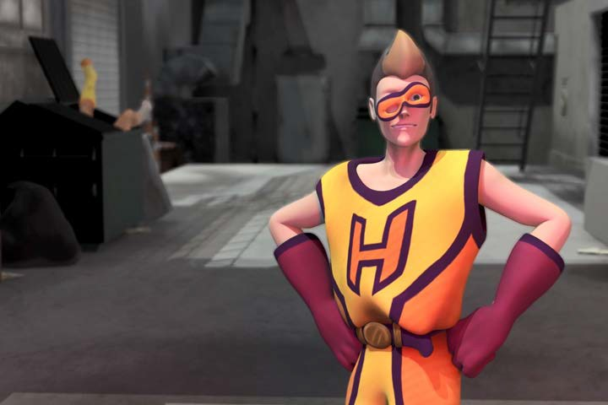 | Animation, fitting alt. outfit for character | Maya

